Name:saqba Yasmin
Sap id :61996
Lab : 10
Tasks : 1

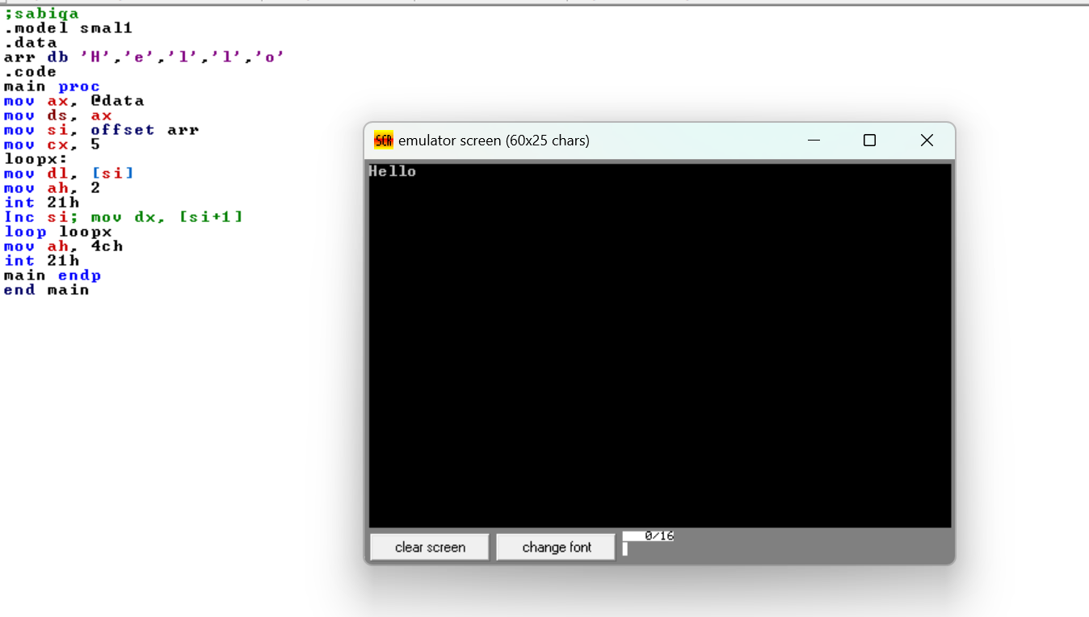

Tasks : 2
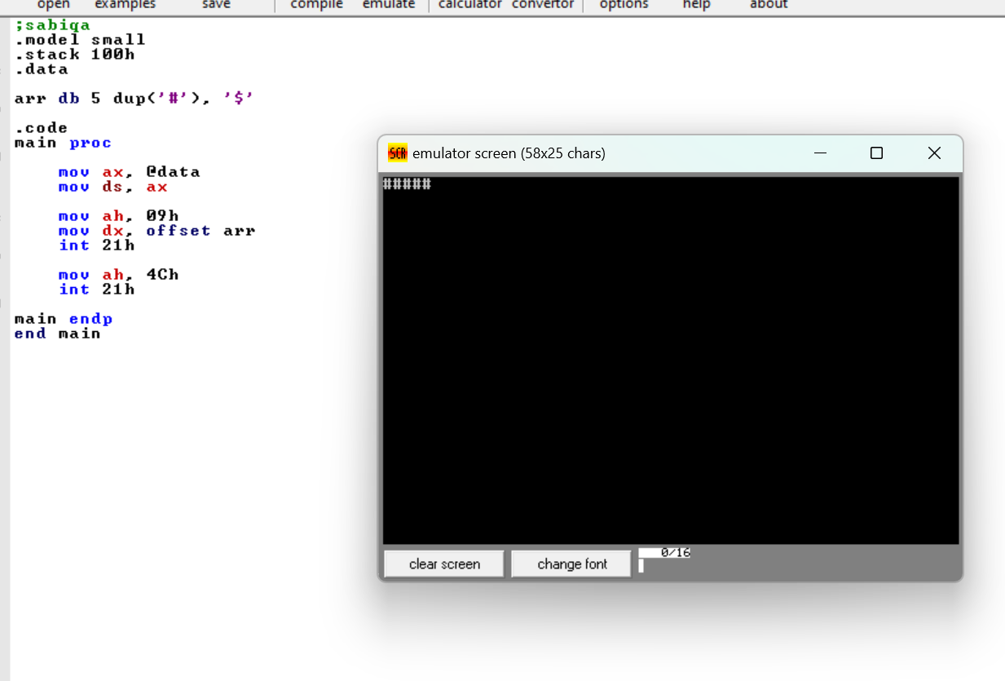

Tasks :3
